Intimations,

~ Midweek service there will be no service this week.

~ Easter Breakfast tickets will be on sale after this morning’s service,
Adults £5, 5-16years £2.50.

~ Messy Church Tuesday 26th March, Mosspark bowling club 4.50 – 6.30pm.

~ The 100 Envelope Challenge is a fundraiser aimed at raising £5,050 towards the cost of building a new disabled toilet in our church halls. Placed at the back of the sanctuary on a table, is a wooden church containing 100 envelopes marked from 1 – 100. You are invited to choose an envelope, marked with the sum you wish to give to the cause, and return it via the church collection bag before or by the 17th May, 2024. Inside the envelope is a letter of explanation and on the back of the letter is a Gift Aid Declaration if you are willing and able to increase the value of your donation by 25%. Everyone’s support and participation would be greatly appreciated. Thank you.

🌺🌺🌺 Flowers today have been kindly donated by The Flower Committee 🌺🌺🌺

Sherbrooke Mosspark Parish Church, 240 Nithsdale Road, Glasgow, G41 5AD
Tel: 0141 427 1968 – Email: sherbrooke-init@btconnect.com
Website: www.sherbrookemosspark.com – CCL 242960/342327 Church Officer – Rebekah Dillon 07399609707 smpchurchofficer@gmail.
Sherbrooke Mosspark Parish Church

Minister: Rev Adam Dillon
Organist: Mr Tom Ferguson

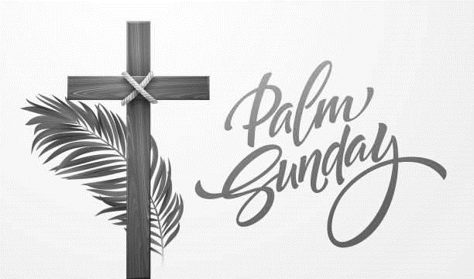

Sunday 24th March 2024
Palm Sunday

Welcome & Intimations

Introit
- Lift up your heads - Psalm 24, verses 9-10;
Music by Tom Ferguson

Call to Worship

Hymn 458
- At the name of Jesus

Opening Prayer and Lord’s Prayer
Our Father, who art in heaven,
hallowed be thy name;
thy kingdom come;
thy will be done;
on earth as it is in heaven.
Give us this day our daily bread.
And forgive us our debts,
as we forgive our debtors
And lead us not into temptation;
but deliver us from evil.
For thine is the kingdom,
the power and the glory,
forever, Amen.

- The Wonky Donkey

Hymn 367
- Hosanna, loud Hosanna

New Testament Mark 11:1-11 (p.45)
Read by Neil Buchanan

Anthem
- Ride on, Ride on in Majesty
Words by Henry Hart Milman (1791-1868)
Music adapted from Musikalisches Hand-Buch, Hamburg, 1690

Hymn 364
- All glory laud and honour

Sermon
- Examining the story

Organ Reflection
- Christe, du Lamm Gottes - Sigfrid Karl-Elert

Prayers of thanksgiving and intercession

Hymn 449
- Rejoice the Lord is King

Blessing

Organ Voluntary
- Palm Sunday Procession - June Nixon

You were welcomed to church today by John Duthie, Brenda Duthie,
Christine Macmillan, Kary O’Brien & Pat McIntyre.

